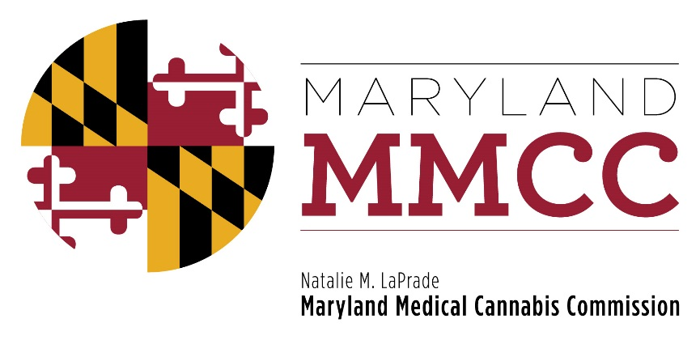
Maryland Medical Cannabis Commission
Committee Meeting
Tuesday, October 3, 2017
2:00 pm
Winchester Hall, 1st Floor Meeting Room
12 East Church Street
Frederick, Maryland 21701

AGENDA

- Call to Order and Welcome: Brian Lopez, Chairman
- Approval of the Minutes: August 28, 2017 Meeting
- Executive Director’s Report
- Committee Reports
- Subcommittee Report: Final Review Subcommittee
- New Business
- Adjournment

